EXPERIMENT-4.
PUSH BUTTON SWITCH INTERFACE-DOOR BELL CONTROL
AIM-Design a door bell using push button.
APPARATUS-Arduino,Resistance 470 ohm,wires,breadboard,push button
CIRCUIT DIAGRAM:
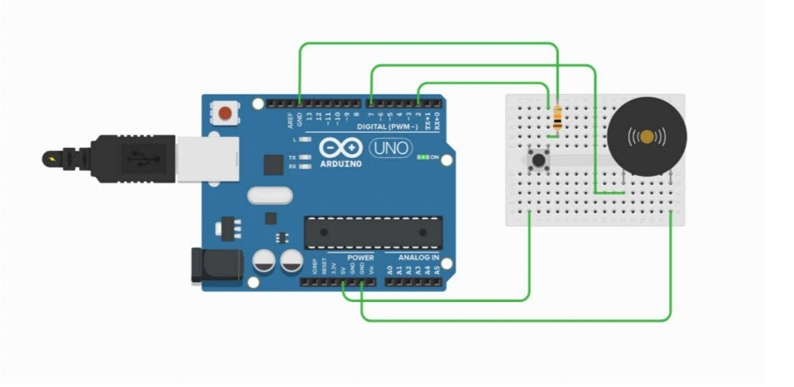
THEORY
CONCEPT USED:-
- We have used pushbutton as a switch
- Each time you press the button,the bell will start making noise.
Learning and observation:-
- I have learned how we can use switch to operate different devices.
Problem and troubleshooting:
- Port selection should be done properly where you have connected arduino to the system .
- connections were loose.
- switch was not working.
Precautions:
- Make sure the connections are proper.
- Select the appropriate port.
- Make sure the connections are not loose.

Learning outcome:
- I learned how we can use a simple switch to make a door bell.
- I also gained some basic knowledge of arduino.

